**Instructions:**

**You can use Word, Excel, Power Point and SAS to answer the questions in this exam. There are a total of six (6) multi-part questions, with point values noted for each question.**

**Please show your calculations, or the details of your program(s) for each problem. Include your SAS programs and output in your submission. The SAS programs should be commented so that each step is clearly explained.**

**Combine all your answers/files into a single zipped file and post the zipped file to “Final Submissions” in Moodle.**

**Problem #1: (15 points)**

X number of high school students are scored on various tests, such as science, math, and social studies (**socst**). The variable **female** is a dichotomous variable, coded 1 if the student was female and 0 if male. Using the multiple regression analysis results below, answer the following questions:

* How many students were scored?
* Is the overall model significant?
* What is the F-value (1-?)?
* What is the R-square for this model (2-?)?
* What is the formula for this model?
* Is this a good model? Why or why not?
* Would you change the model? If yes, How?

| **Analysis of Variance** | | | | | |
| --- | --- | --- | --- | --- | --- |
| **Source** | **DF** | **Sum of Squares** | **Mean Square** | **F Value** | **Pr > F** |
| **Model** | 4 | 9543.72074 | 2385.93019 | **1-?** | <.0001 |
| **Error** | 195 | 9963.77926 | 51.09630 |  |  |
| **Corrected Total** | 199 | 19508 |  |  |  |

|  |  |  |  |
| --- | --- | --- | --- |
| **Root MSE** | 7.14817 | **R-Square** | **2-?** |
| **Dependent Mean** | 51.85000 | **Adj R-Sq** | 0.4788 |
| **Coeff Var** | 13.78624 |  |  |

| **Parameter Estimates** | | | | | | | | |
| --- | --- | --- | --- | --- | --- | --- | --- | --- |
| **Variable** | **Label** | **DF** | **Parameter Estimate** | **Standard Error** | **t Value** | **Pr > |t|** | **95% Confidence Limits** | |
| **Intercept** | Intercept | 1 | 12.32529 | 3.19356 | 3.86 | 0.0002 | 6.02694 | 18.62364 |
| **math** | math score | 1 | 0.38931 | 0.07412 | 5.25 | <.0001 | 0.24312 | 0.53550 |
| **female** |  | 1 | -2.00976 | 1.02272 | -1.97 | 0.0508 | -4.02677 | 0.00724 |
| **socst** | social studies score | 1 | 0.04984 | 0.06223 | 0.80 | 0.4241 | -0.07289 | 0.17258 |
| **read** | reading score | 1 | 0.33530 | 0.07278 | 4.61 | <.0001 | 0.19177 | 0.47883 |

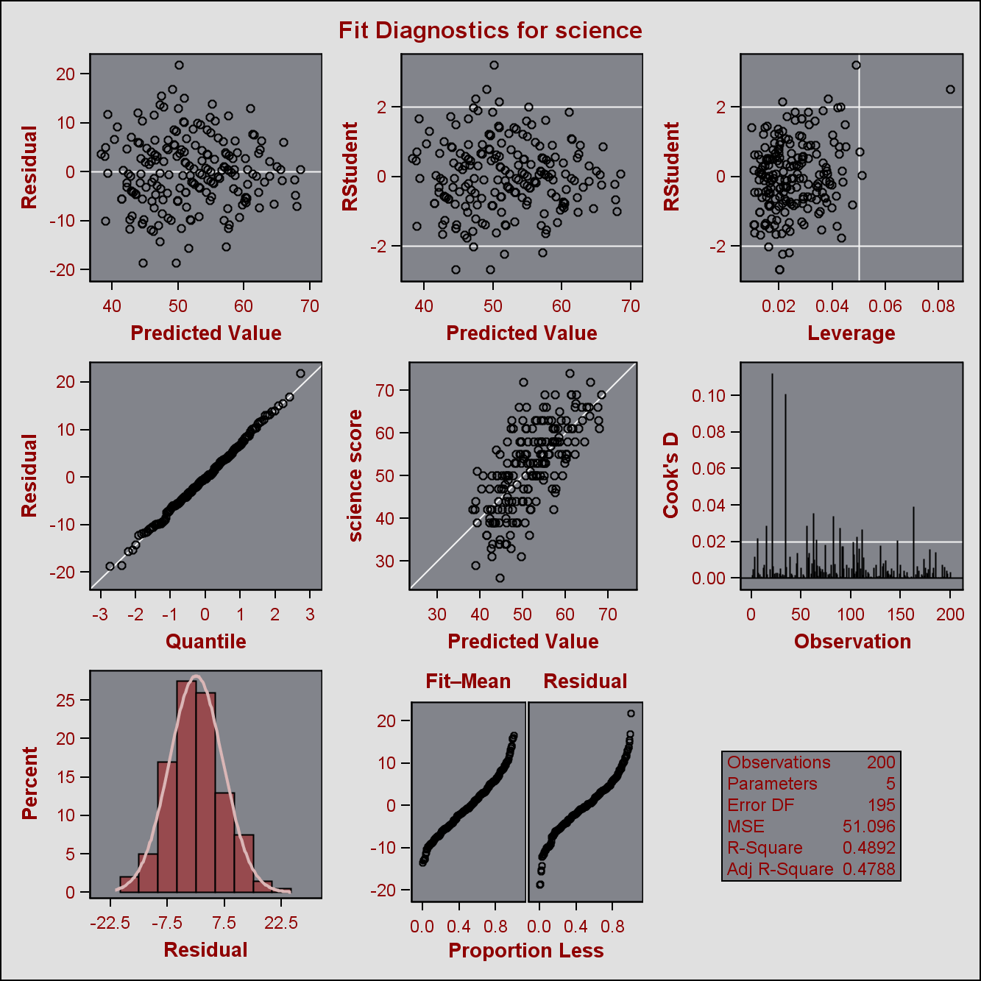

**Answer:**

* How many students were scored?

There are 200 students scored since the number of students is the number of corrected totally plus 1.

* Is the overall model significant?

The overall model is significant because Pr<0.0001.

* What is the F-value (1-?)?

F-value=MSR/MSE=2385.93019/(7.14817)^2=46.69477

* What is the R-square for this model (2-?)?

R-square=SSR/SST=9543.72074/19508=0.4892

* What is the formula for this model?

Y=12.32529+0.38931*math-2.00976*female+0.04984*socst+0.33530*read

* Is this a good model? Why or why not?

This is not a good model. Even if it is significant and the residual distributes evenly. But the coefficients of variables are not that significant, especially the Pr for socst is 0.4241. So ingeneral it is not a good model.

* Would you change the model? If yes, How?

Yes. I would remove the variable socst-social studies score because the variable is not significant.

**Problem #2: select one (5 points)**

A software package has produced the following output for a regression model estimating the nutritional ratings of cereals, based on the location of the cereal on a super market shelf (shelf1, shelf2). Is this model a good regression model?

| **Parameter Estimates** | | | | | |
| --- | --- | --- | --- | --- | --- |
| **Variable** | **DF** | **Parameter Estimate** | **Standard Error** | **t Value** | **Pr > |t|** |
| **Intercept** | **1** | 45.22003 | 2.23245 | 20.26 | <.0001 |
| **shelf1** | **1** | 0.92541 | 3.73561 | 0.25 | 0.8050 |
| **shelf2** | **1** | -10.24721 | 3.67798 | -2.79 | 0.0068 |

1. The model is NOT a good model because variable shelf2 and “Intercept” are not significant at 5%
2. The model is NOT a good model because variable shelf1 is not significant at 5%
3. The model is NOT a good model because the location of cereal (“shelf1 vs. shelf2) has nothing to do with ratings and cannot cause a change in cereal ratings.
4. Both I and III

**Answer:**

The correct answer is II: The model is NOT a good model because variable shelf1 is not significant at 5%.

**Problem #3: (20 points)**

1. Use the Lung dataset in CANVAS, and forward, backward, and stepwise selection methodologies to develop multiple regression models for “HEIGHT of Oldest Child” as dependent variable and “AGE of Oldest Child”, “WEIGHT of Oldest Child”, “HEIGHT of Mother”, “WEIGHT of Mother, “HEIGHT of Father” and “WEIGHT of Father” as independent variables. (Do not perform any data transformation).
2. Find the best subset of the three variables

**Answer:**

I.The code as following graph

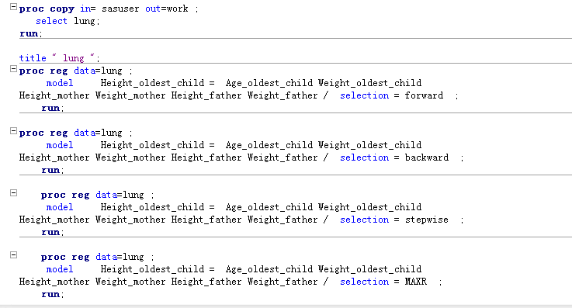

1.Model construction

Construct a regression model by lung data-set using all the variables. Then we can get the results as following pictures.

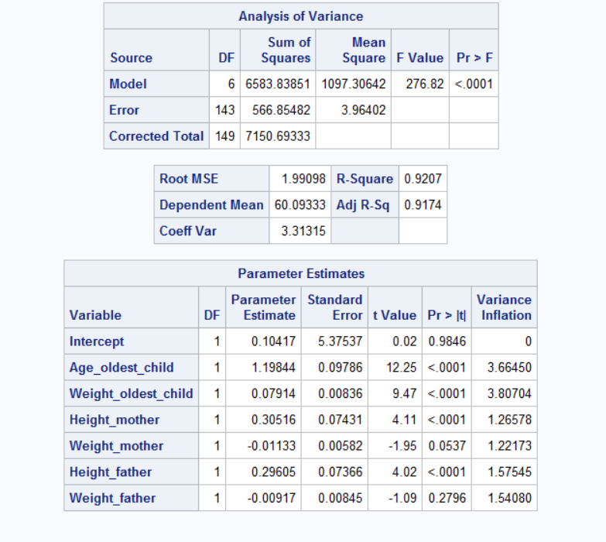

The overall model is good. However, the variable Weight_mother and Weight_father are not significant based on the 5% assumption. What’s more, the vif is low for each variable, which means they are not dependent on each other.

2.Forward selection

Codes:

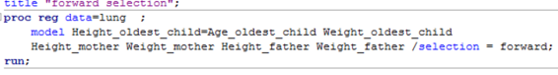

Then we can get the result as following graphs:

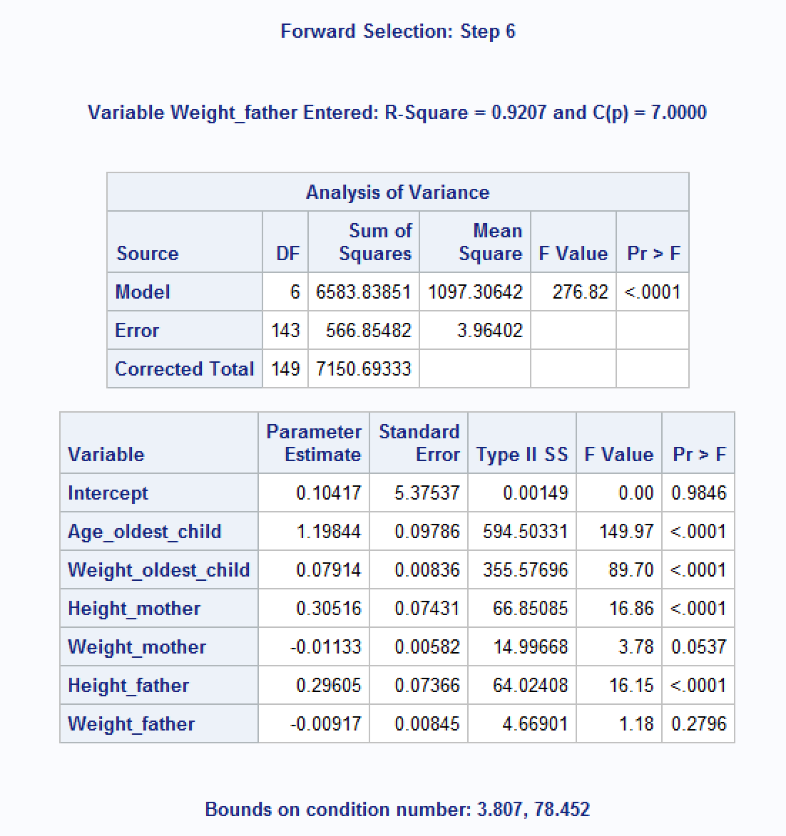

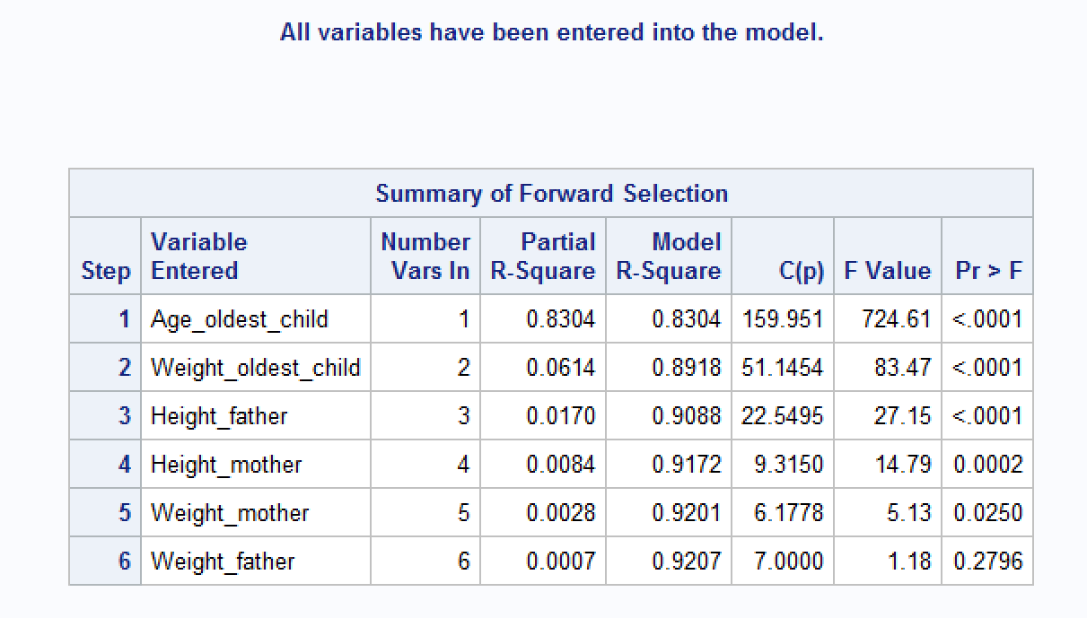

3. **Backward Selection**

**Codes as following:** 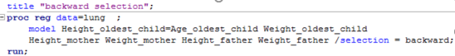

Then we can get the results: 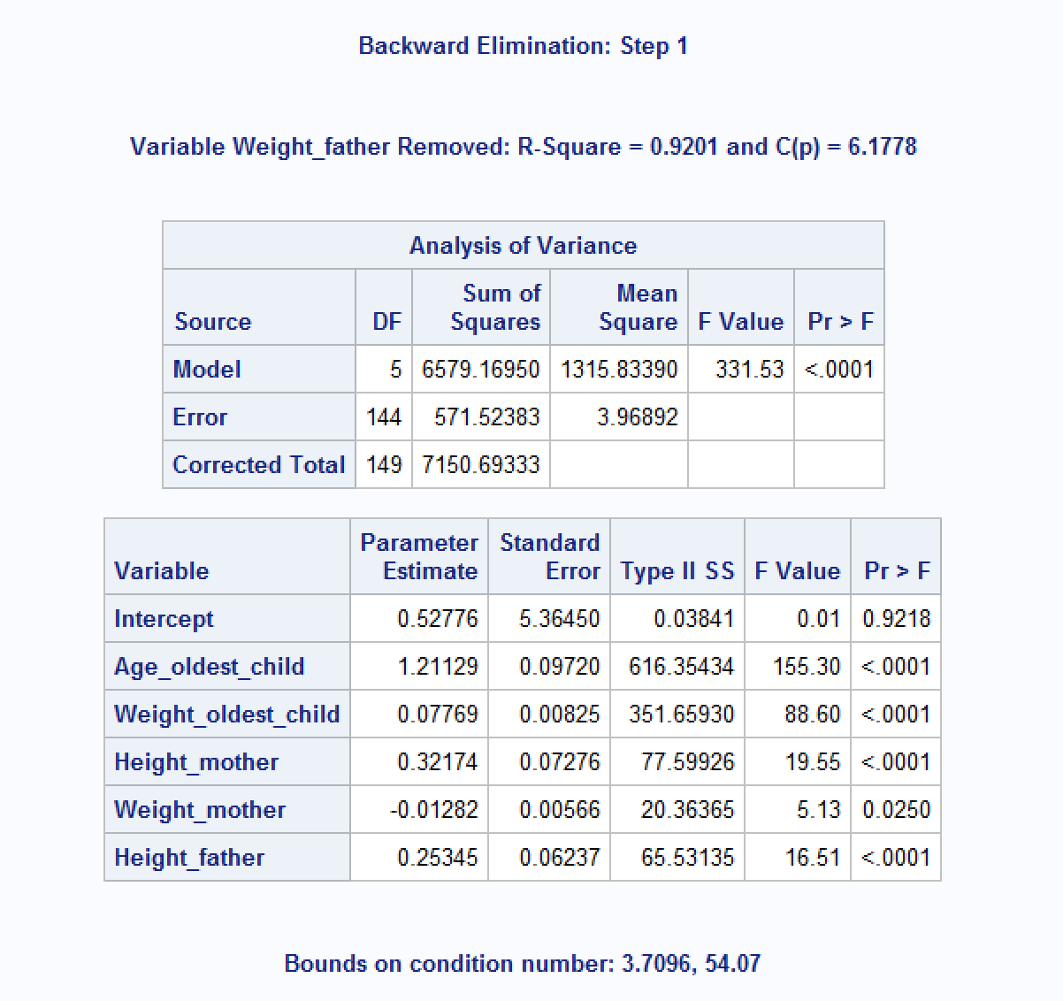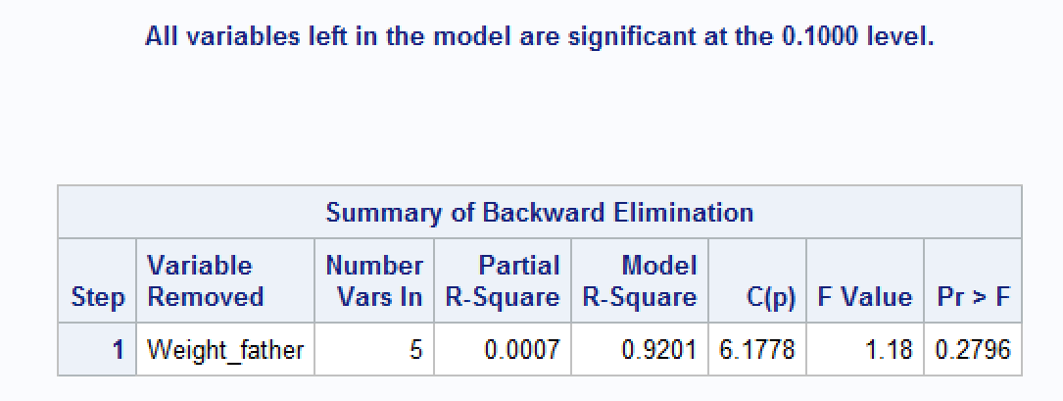

**4.Stepwise Selection**

**Codes as following:** 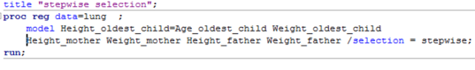

Then we can get the results: 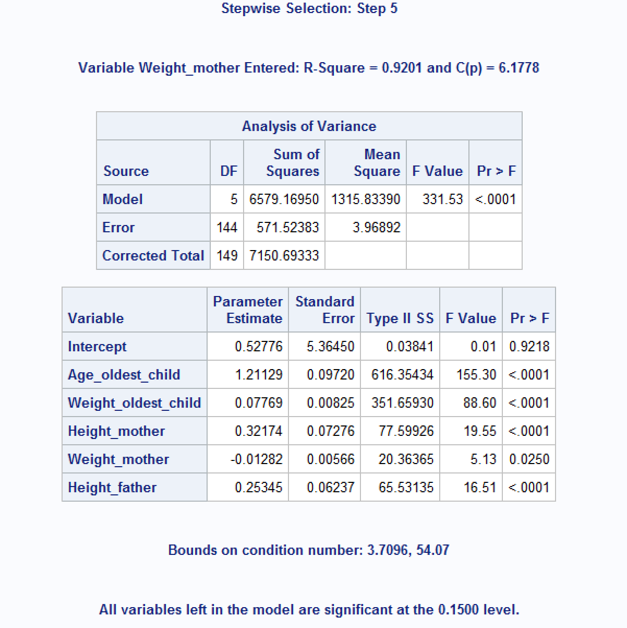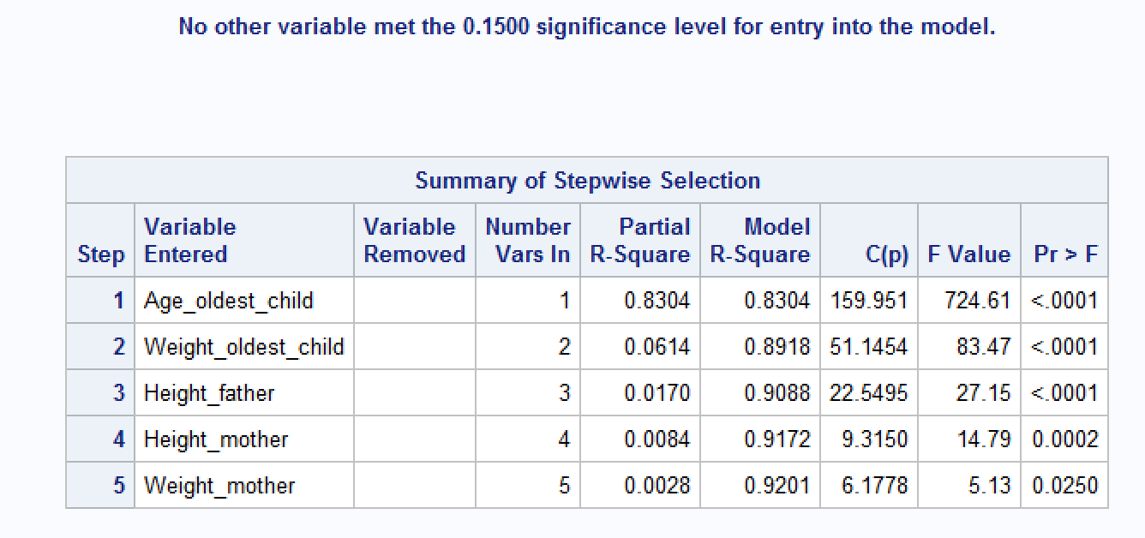

**II.** We could use MAXR selection to solve this problem. The codes as following: 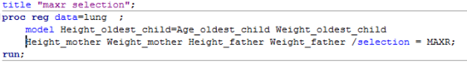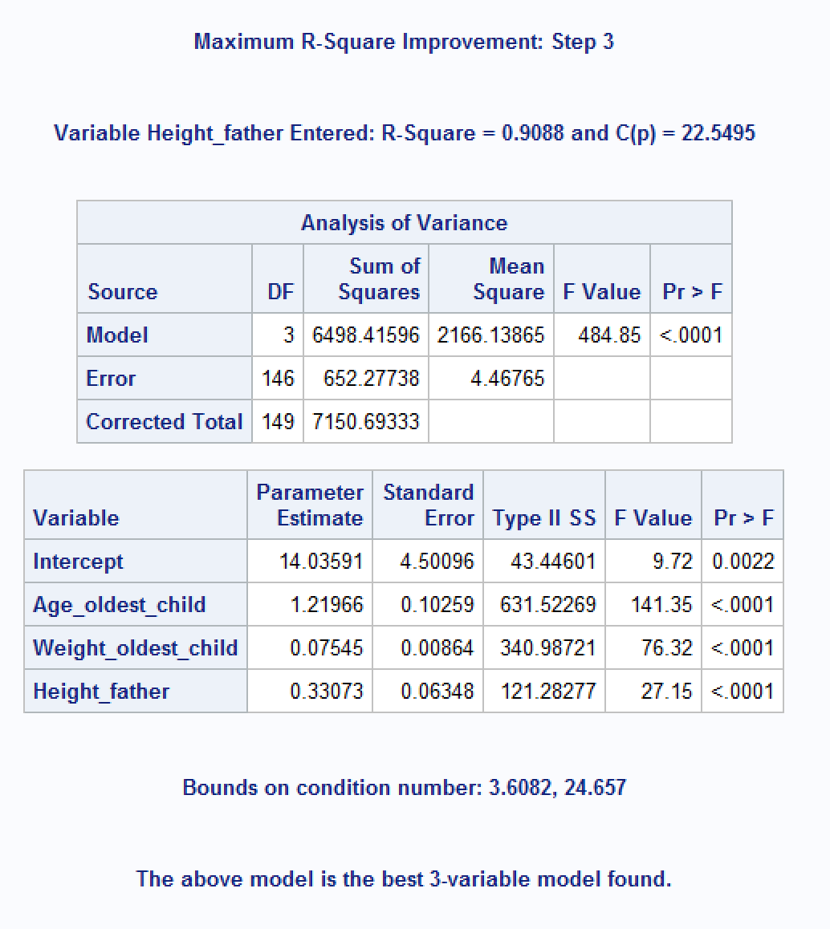

As it show in the graph, the best three variables is Age_oldest_child, Weight_oldest_child and Height_father

**Problem #4: (20 points)**

The “heart attack” dataset in CANVAS contain the records for twenty heat attack patients. The dependent variable (Heart_Attack_2) is an indicator showing whether the patient has had a second heart attack within 1 year (yes=1). The first independent variable “Anger Treatment”, indicates whether the patient completed an anger management treatment or not. The second independent variable (“Anxiety Treatment) shows the level of anxiety treatment of the patient.

1. Develop a logistic regression model for predicting the probability of the patient having s second heart attack (show your development steps)
2. Using your model:
   1. Predict the probabilities of the following two patients (A and B) having a heart attack within the next year?

|  |  |  |
| --- | --- | --- |
| Patient | Anger Treatment | Anxiety Treatment |
| A | 1 | 40 |
| B | 0 | 70 |

* 1. What are the odds for patient A and patient B?
  2. What is the odds ratio of A over B?

**Answer:**

**I.** **Develop a logistic regression model for predicting the probability of the patient having s second heart attack (show your development steps)**

**Solution:**

1. develop a logistic regression model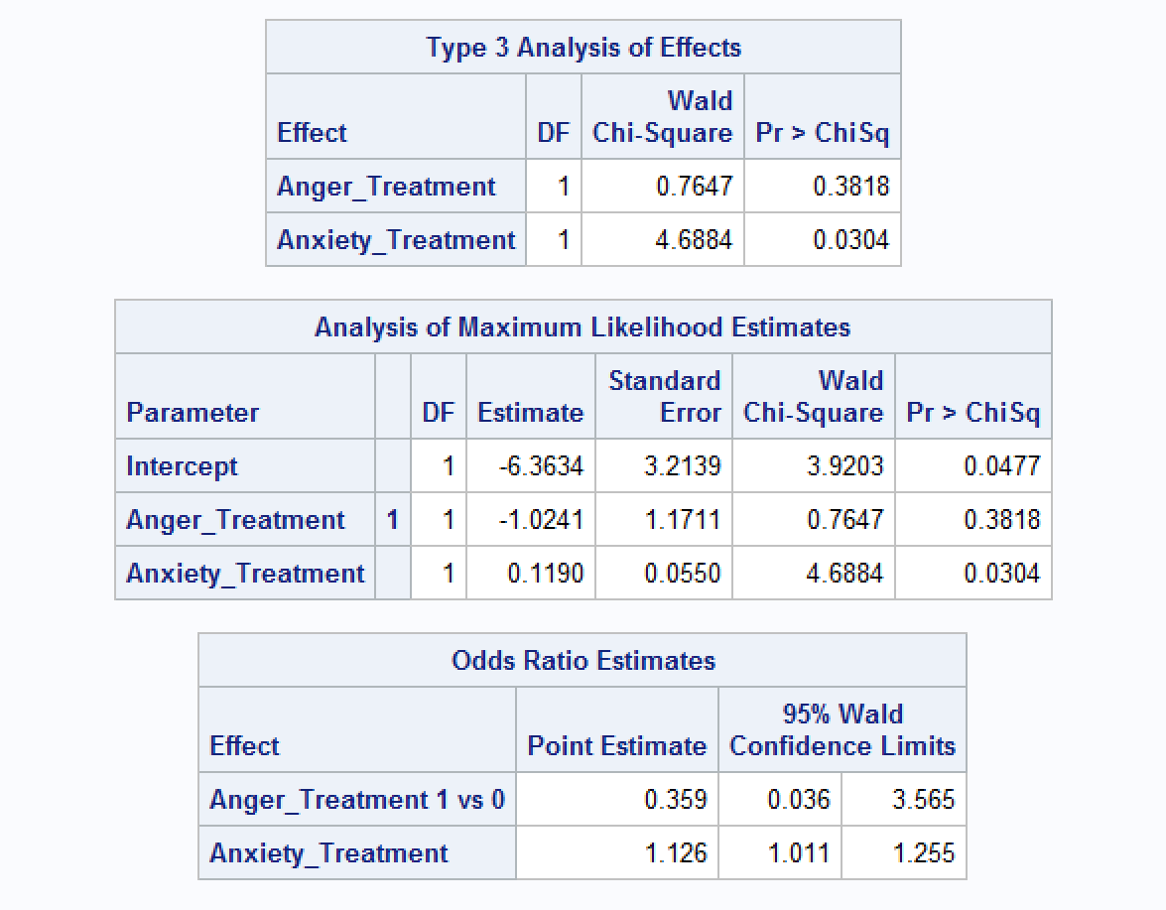

We can conclude that variable Anger_Treatment is not significant, so the next step we remove it from the model. The codes as following:

C:\Users\dell\Desktop\捕获.PNG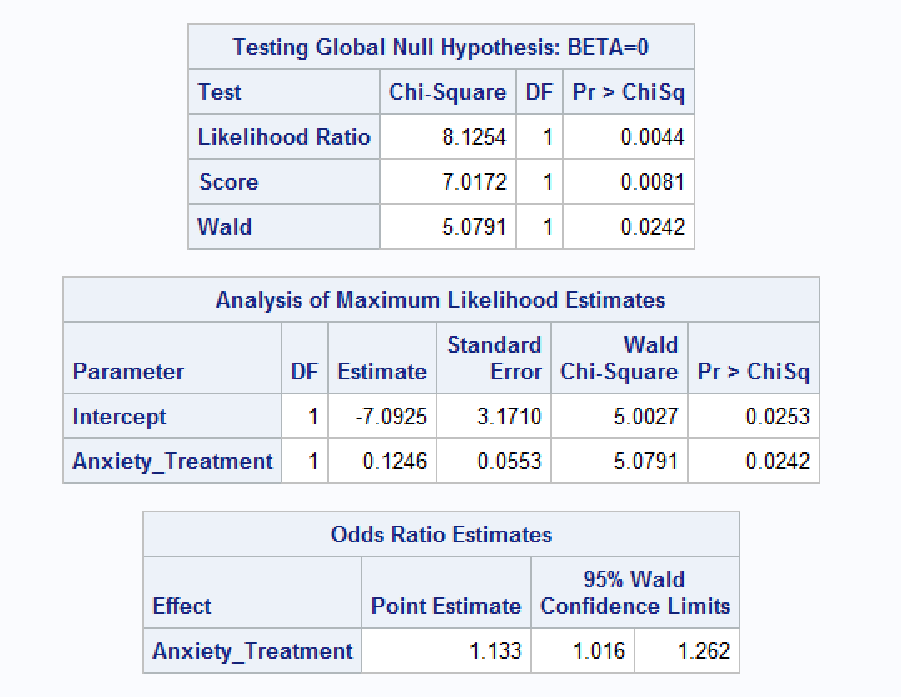

We can conclude that the significance of Anxiety_Treatment improves after we remove the variable Anger_Treatment and there is no need to categorize the variable Anxiety_Treatment. So this is model we chose to use.

**II.** **Using your model:**

**a. Predict the probabilities of the following two patients (A and B) having a heart attack within the next year?**

**Patient Anger Treatment Anxiety Treatment**

**A 1 40**

**B 0 70**

**a.** After the remove of Anger_Treatment, the formula is that P(heart_attack)=. For Patient A, the probability to get a heart attack is =0.1082. For Patient B, the probability to get a heart attack is =0.8356

**b.** **What are the odds for patient A and patient B?**

Odds(patient A)=0.1082/（1-0.1082）=0.1213

Odds(patient B)=0.7310/(1-0.7310)=5.0829

**c. What is the odds ratio of A over B?**

Odds ratio(A/B)=Odds(A)/Odds(B)=0.0446

**Problem #5: (20 points)**

The Breast Cancer dataset in CANVAS includes some of the features that are computed from a digitized image of a fine needle aspirate (FNA) of a breast mass. They describe characteristics of the cell nuclei in the image. (Source: UCI). Perform PCA analysis on the following 10 variables.

1. How many principal components should be used to explain at least 85 percent of the variability in data?
2. What if the study requires more than 95 percent of variability to be explained, how many variables do you use?
3. radius_mean
4. texture_mean
5. perimeter_mean
6. area_mean
7. smoothness_mean
8. compactness_mean
9. concavity_mean
10. concave_points_mean
11. symmetry_mean
12. fractal_dimension_mean

**Answer:**

1. How many principal components should be used to explain at least 85 percent of the variability in data?

C

Codes: 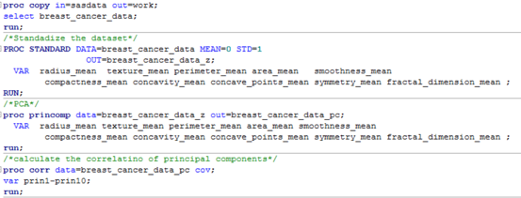

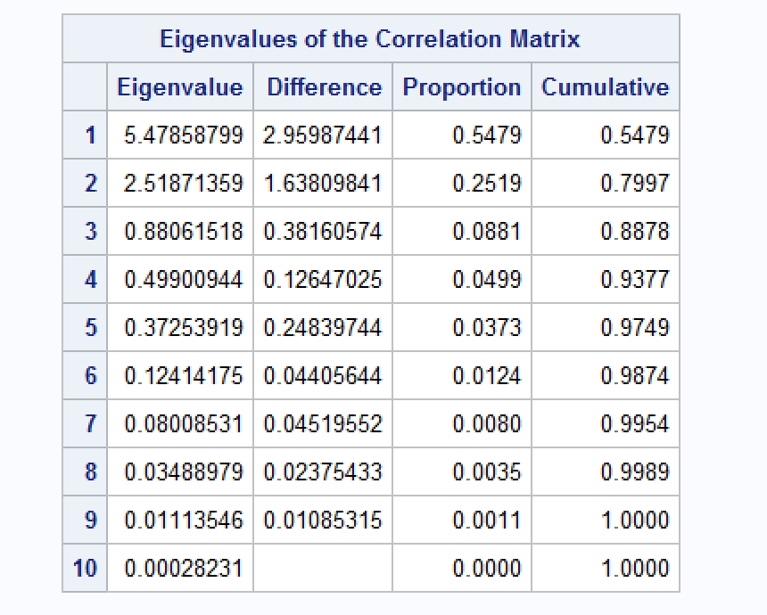

As it shows in the graph,we need 3 principal components to explain at least 85 percent of the variability in the data.

II. From the plot above, we find that we only need ***5*** principal components to explain at least 95 percent variability in the data.

**Problem #6: (20 points)**

Assuming the following web structure, calculate the page rank of nodes A through F.

**Answer:**

**The codes in the 6.sas file. The result as it shows in the graph:**

